SOME OF THE OS USED FOR CYBERSECURITY ARE

* Kali Linux
* Parrot OS
* BlackBox
* BlackArch

Steps to install OS

1. Installing Virtual box

Link: <https://www.virtualbox.org/wiki/Downloads>

Virtual box helps the user to install multiple OS in the computer and work on them simultaneously

For instance virtualbox can help the user to run windows 11 and Ubuntu on MacOS or any such operating system

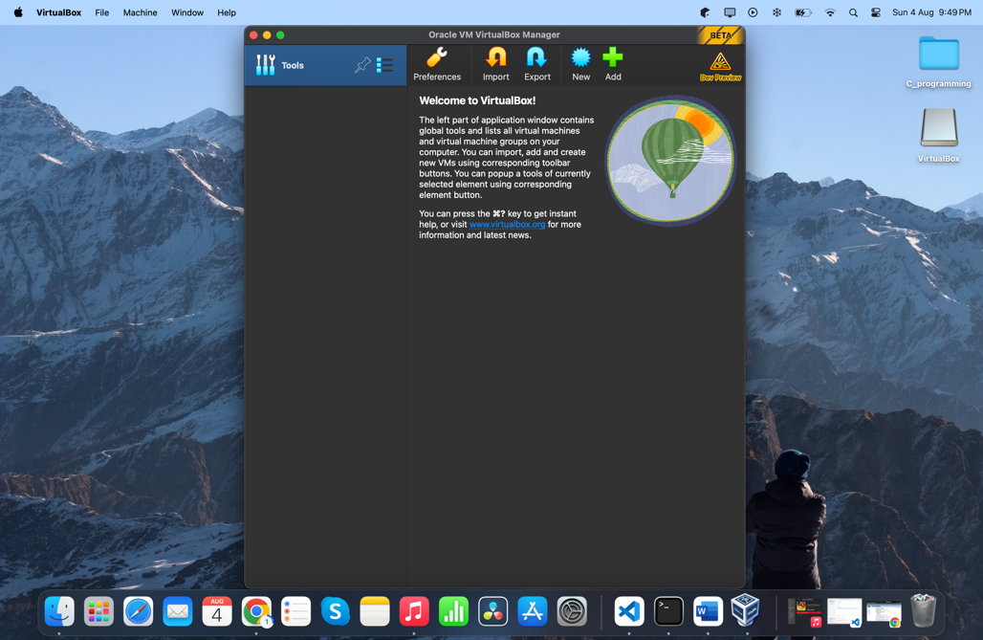

1. Downloading ParrotOS

Link: <https://parrotsec.org/download/>

Parrot OS is a Linux distribution which is focused for security, privacy and is widely used for cybersecurity

Parrot OS has 2 editions

* Home EDITION:

This edition is designed for daily use who would need a lightweight system and can be used for programs such as private chats or to browse any search anonymously.

* Security Edition

Security edition is used for penetration testing, vulnerability assessment and mitigation, computer forensics, and anonymous web browsing.

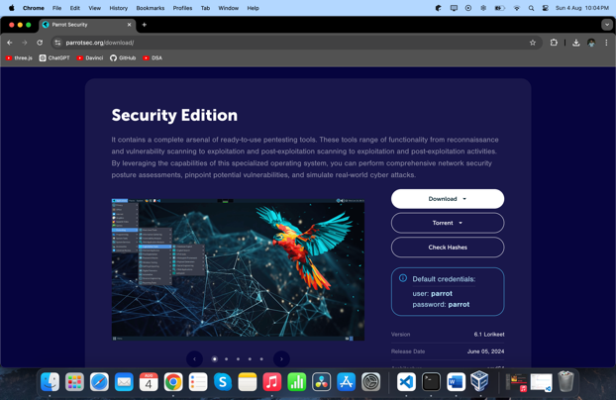

1. Importing ParrotOS into virtualBox

Once the parrotOS is downloaded , it should be imported to the virtualBox

Once importing the OS, we can manually change the settings like RAM and memory which should be allotted to the OS to Run the application as per the user needs, The OS installed will be shown on the Virtual BoxA screenshot of a computer

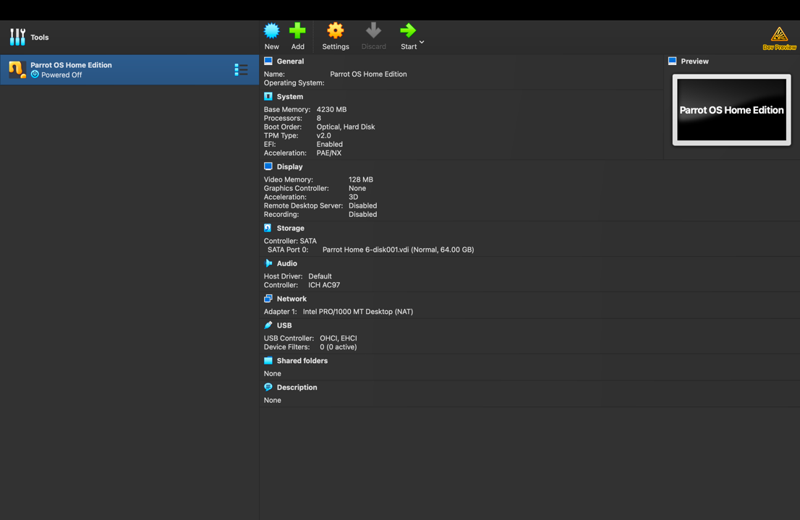

BY FOLLOWING THESE STEPS PARROT OS CAN BE INSTALLED ON MAC OS USING VIRTUAL BOX